Cairo University Faculty of Computers and Information



**Software Engineering II**

**Daily scrum meeting**

**2020**

**Project Team**

|  |  |  |  |
| --- | --- | --- | --- |
| **ID** | **Name** | **Email** | **Mobile** |
|  | Ahmed Sayed | [Ahmed111522@gmail.com](mailto:Ahmed111522@gmail.com) | 01100261796 |
|  | Ashraf Samir | [Ashrafsamer423@gmail.com](mailto:Ashrafsamer423@gmail.com) | 01200977469 |
|  | Hatem Sayed | [Hatemgad98@gmail.com](mailto:Hatemgad98@gmail.com) | 01000275167 |
|  |  |  |  |
|  |  |  |  |
|  |  |  |  |

Contents

Done requirements 2

What will be done today 2

Current obstacles 3

Current Trello workspace 3

# Done requirements

**Ashraf: Sign up class diagram.**

**Hatem: List class diagram.**

**Ahmed: Combine all classes.**

# What will be done today

**Implementation.**

# Current obstacles

**Ashraf: faced a problem with sign up class diagram.**

# Current Trello workspace

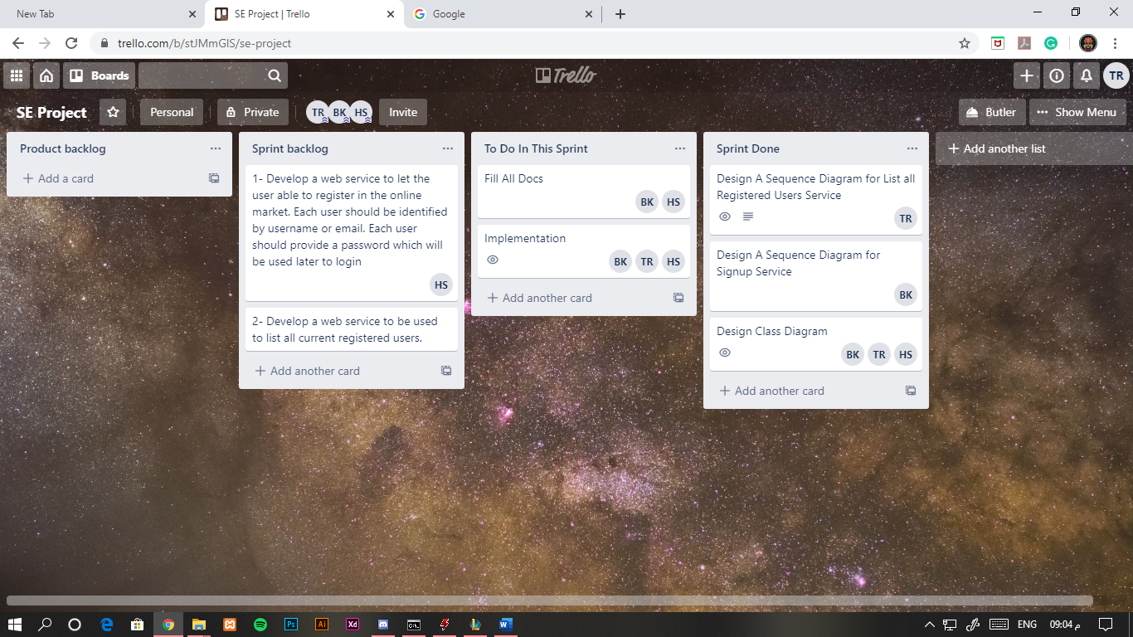

BK: Ahmed Sayed

HS: Hatem Sayed

TR: Ashraf Samir